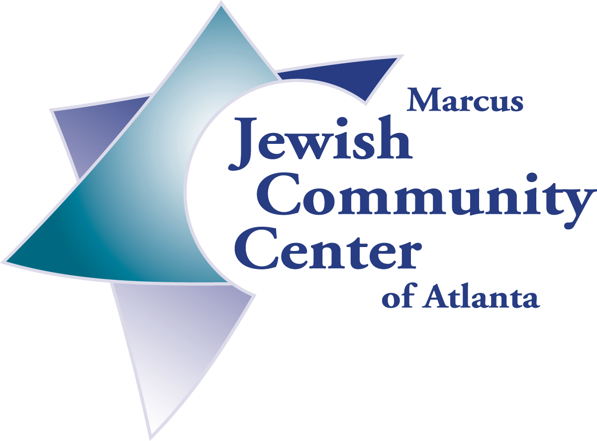

Itinerary June 16, 2003

Marcus Jewish Community Center of Atlanta –International Community Builders (ICB)
Humanitarian Mission to Jewish Cuba

Please note: the following times are estimated

Monday, June 16
Flight from Miami to Havana
Arrive at Jose Marti airport
Meet Miriam, guide and driver at airport
As time allows, see sights
Check in at Telegrafo Hotel
Dinner at Hotel (included)

Tuesday, June 17
Breakfast at Hotel
9:00 Meet with guide and leave for Tour of Old Havana
Get short history of Havana. Visit the model of the city
Visit points of interest
Lunch on your own - not included
1:00 Board bus
1:30 Visit Patronato deliver donations
Meet with Dr. Miller(president of community) , Adela Dworin,
(vice-pres.), Nestor and Mara (JDC Representatives), Isaac Rousso
(B’nai Brith President), and others.
2:00 Visit the Pharmacy at Patronato deliver donations
Meet with Dr. Rosa Behar, Head of Pharmacy
3:30 Visit Templo Sepharadi deliver donations
Meet with Jose Levy
5:00 Return to Hotel - ready for evening
7:30 Evening: Cuban dinner at Aljibe- included

Wednesday, June 18
Breakfast at Hotel
Check out
9:00 Drive by Cojimar, Hemingway’s fishing village
10:00 Visit Jewish Cemeteries-Service at site of Holocaust memorial
11:00 Leave for Cienfuegos
Lunch on the road - not included
3:00 City Tour of Cienfuegos
4:00 Check into La Union Hotel
6:00 Visit Rebecca Langus, leader of community (Mincha Service) deliver donations
8:00 Dinner at hotel

Thursday, June 19
Breakfast at Hotel
8:30 Check out of Hotel
9:00 Leave for Trinidad (visit with family doctor on the way
10:30 Arrival in Trinidad, tour city
1:00 Lunch at Trinidad del Mar - included (Havanatur knows of early arrival)
4:00 Check in at Trinidad del Mar - all inclusive hotel
Afternoon at leisure
7:00-10:00 Dinner at Hotel - Buffet
You can arrange for evening activities in Trinidad

Friday, June 20
Breakfast
7:00 Check out
7:30 Depart for Santa Clara
10:30 Arrive in Santa Clara

11:00 Meet with David Tacher, leader of Santa Clara Community ,
(prayer service) deliver donations
1:00 Depart for Havana (Lunch on the road, not included)
5:00 Check into Telegrafo
6:00 Services at Patronato
8:00 Dinner at Patronato Meet with community members

Saturday, June 21
Breakfast at Hotel
9:45 Depart for Shabbat Services at Adat Israel deliver donations 12:00 Lunch at Adat Israel with members
1:00 Free Afternoon
4:00 Meetings to be announced at hotel
Havdalah Service
Free evening-can arrange dinner at Paladar –not included

Sunday, June 22
8:00 Breakfast Meeting
10:30 Leave for Patronato Sunday School deliver donations Meet with Dr. Mechulan, teachers and kids
Interact with children
12:30 Free Time
7:00 Depart for Farewell Dinner at Café Del Oriente – included

Monday, June 23
Breakfast Meeting - last minute details

Check out
Be sure you have passport, visa, tickets and $25.00 Cuba exit tax
Any extra weight - $2.00 per pound
Leave for airport

Trip Costs Include
Basic Trip (Havana Fight, Hotel, guide, driver and transportation)
All meals that are "included"
Tips for Bellboys, Guide and Driver (basic- can give extra for superb service)
Daily drinks in bus ( 2 per person)
Visa
License
Medical insurance
Exit taxes
Cash donations to Jewish communities

Please note: hotels may change based upon availability

